So, you think you might want to study A level Physics?
Good plan. It’s a lot less boring than GCSE, for you to learn and for us to teach.
To study physics at A level, you will need at least a grade 6 in Mathematics and:
- Separate scientists will need a 6 in Physics, plus a grade 6 in another science.
- Dual scientists (Trilogy or combined science) will need at least a 6-6.
These are minimum grades, we prefer you to have both maths and physics at grade 7 or higher, as we will assume a good knowledge of the GCSE material, we will not be re-teaching it.
There is a lot of mathematics involved in the study of physics more so at A Level, than you will have seen at GCSE, so if you are good at maths, you will enjoy Physics more at A Level than GCSE.
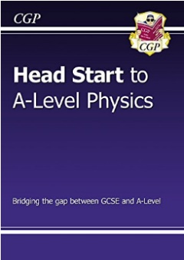
A Level textbooks and revision guides can be found on Firefly at https://wilmslowhigh.fireflycloud.net/physics-1/textbooks-and-revision-guides. An online version of the OXFORD textbook is available at www.kerboodle.com where you can log in with your own details.
Head start to A Level Physics
Working through these books are an excellent way to get you ready for the start of the A Level Physics course

Crash Course produce good videos (American, but don’t let that put you off). Each video is ~ 15 minutes long and gives you a good feel for the topics

Physics Astronomy Engineering
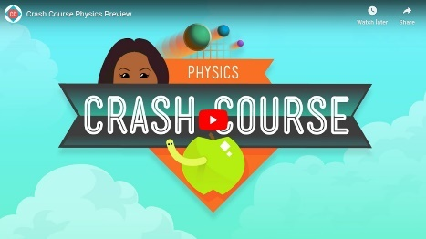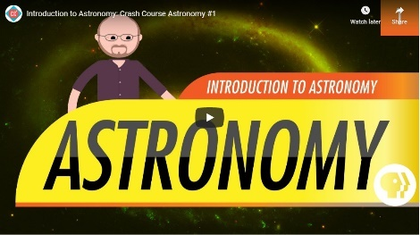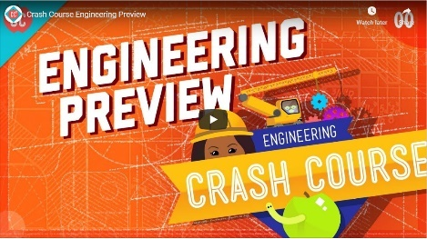
Images are hyperlinked – click on the image to access the videos.
To do: We have developed a Year 11 to Year 12 transition guide in Firefly. Note that some of the tasks also appear in the summer work you will be asked to do. https://wilmslowhigh.fireflycloud.net/physics-1/gcse-to-a-level-transition

We will be emailing out some summer work to be completed before re-joining us in September. The Isaac Physics boards suggested in the transition guide will also be included in the summer work - you will only need to complete the questions once, of course.

Isaac Physics group class code for students starting in 2023 is: V989BN
On this page are some videos that you may find interesting. The images are hyperlinked. If you would like to suggest any of your favourites for me to add to this page, please email me with the link: ndavies@wilmslowhigh.com
Electricity
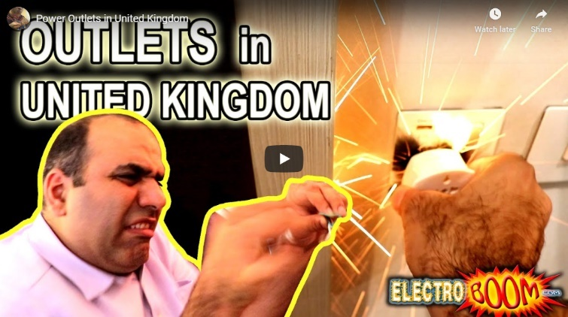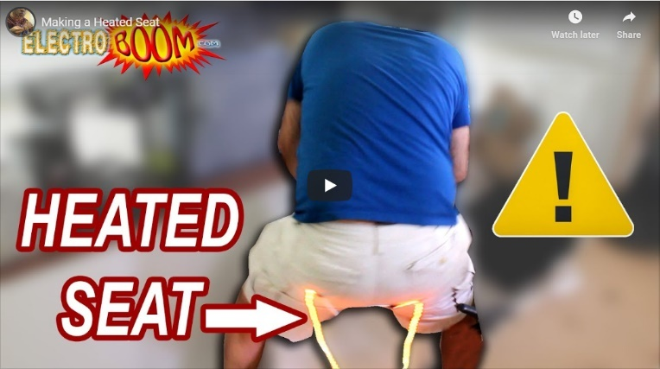
Particle and Quantum Physics
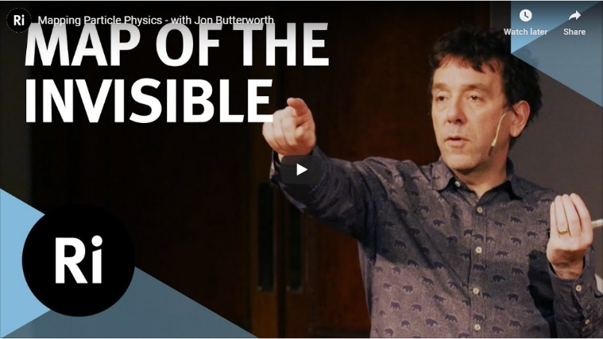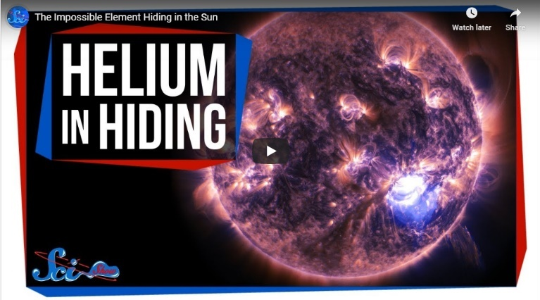
Waves and Optics
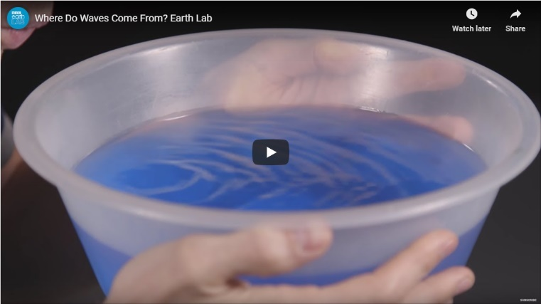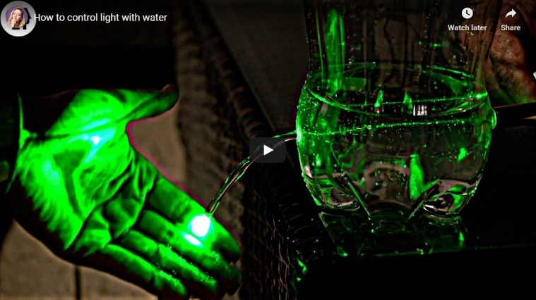

Fields
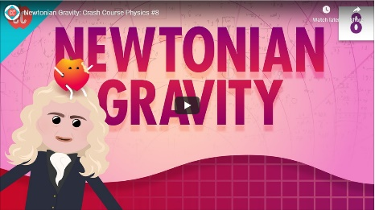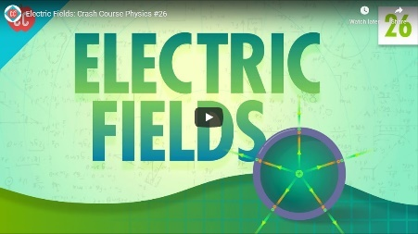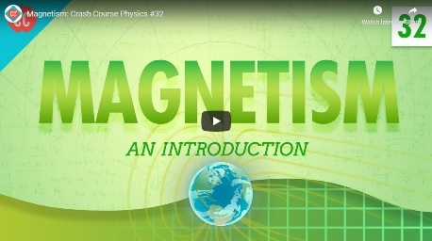
Nuclear Physics
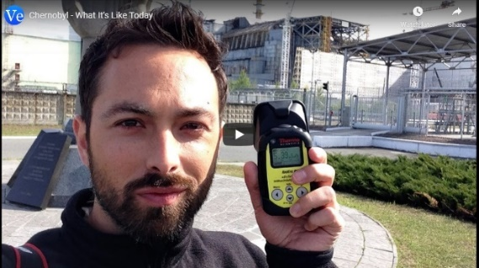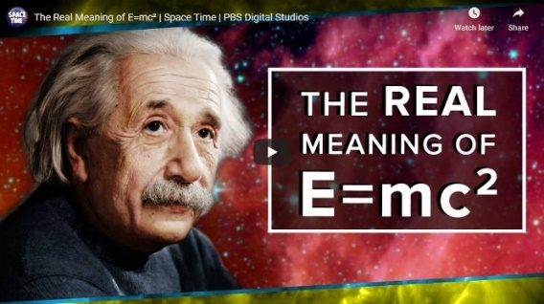
Astro-Physics
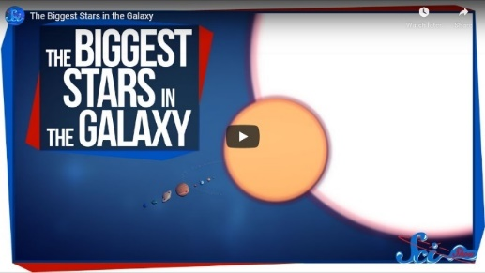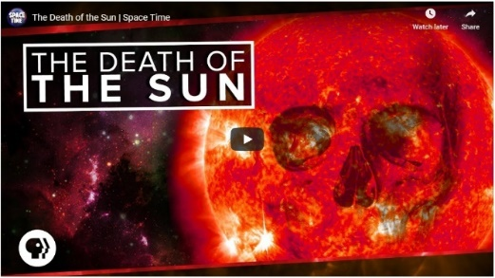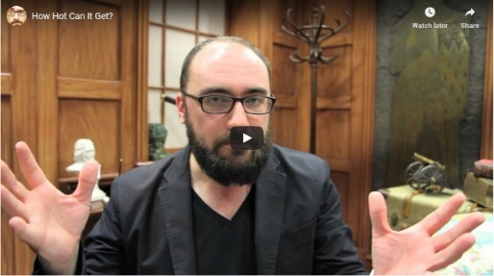
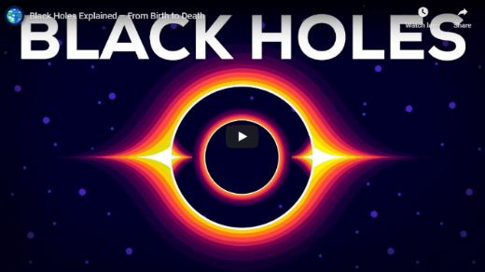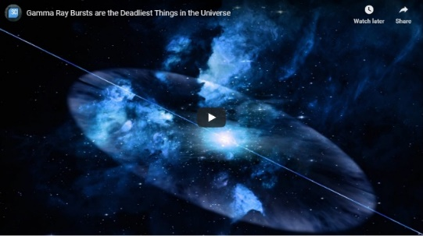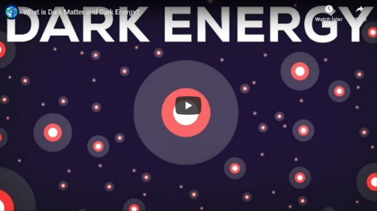
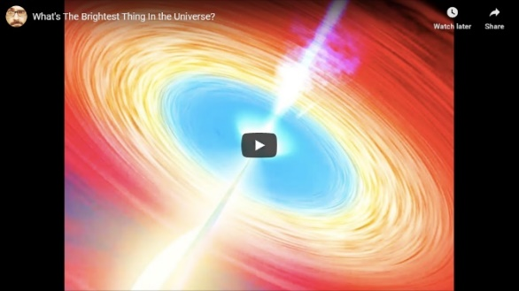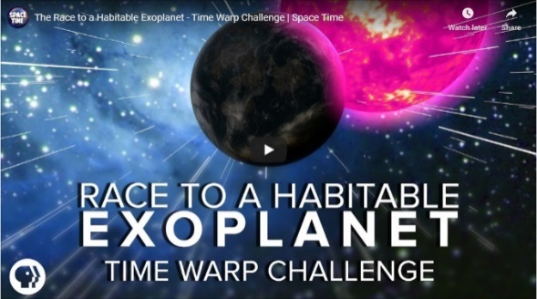
All of these videos (and many more) can be found on Firefly: https://wilmslowhigh.fireflycloud.net/physics-1/great-a-level-physics-videos
Y11/13 Suggested summer reading. I suggest you click on the Amazon links to find out what these books are about before buying. Next to each book is the year groups aimed at.

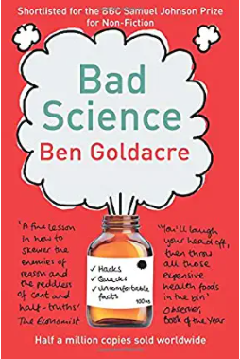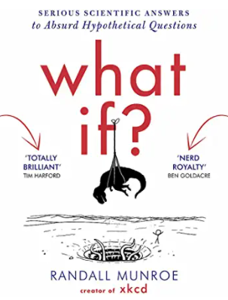

Bad Science(Y10-13)

What If Serious Scientific Answers to Absurd Hypothetical Questions (Y10-13)
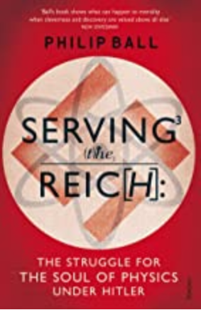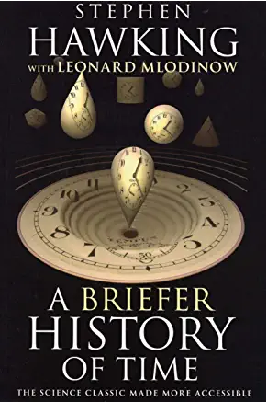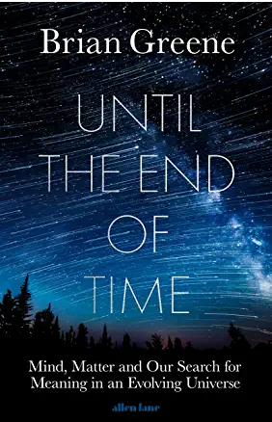

Serving the Reich - The struggle for the Soul of Physics under Hitler (Y10-13)

Until the End of time (Y13)

A Briefer History of Time (Y11-13)
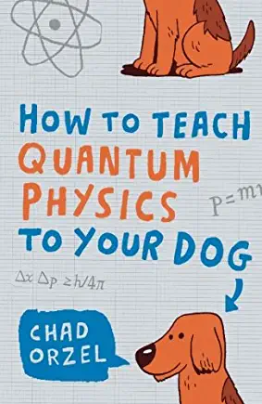 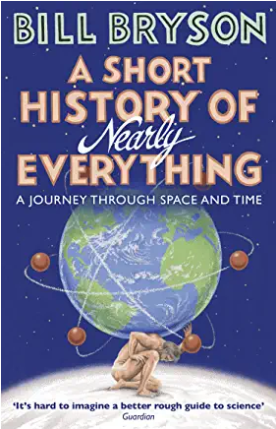Y10-13 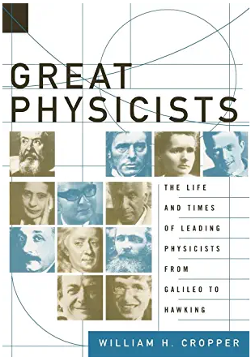 Y11-13

How to teach Quantum Physics to your dog (Y11-13)

A Short History of Nearly Everything (Y10-13)

Great Physicists: The Life and Times of Leading Physicists from Galileo to Hawking (Y11-13)
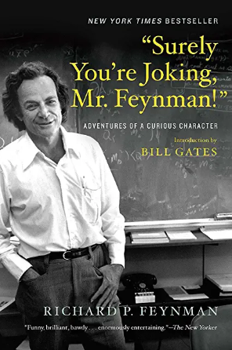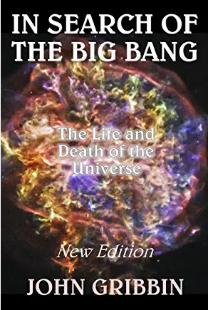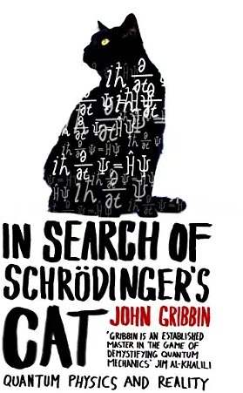
"Surely You're Joking, Mr. Feynman!": Adventures of a Curious Character (Y13)
In Search of the Big Bang: The Life And Death of the Universe (Y13)

In Search Of Schrodinger's Cat (Y13)
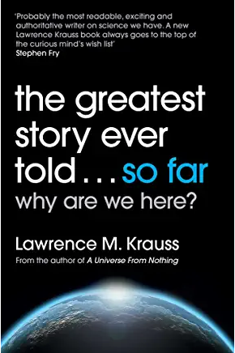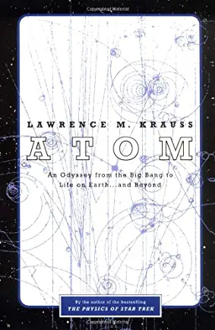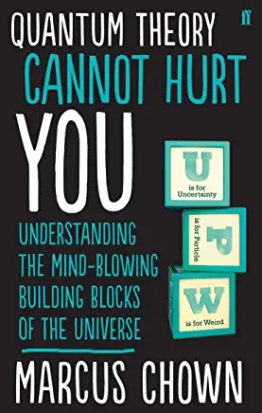

The Greatest Story Ever Told...So Far (Y13)

Atom: An Odyssey from the Big Bang to Life on Earth... and Beyond (Y13)

Quantum Theory Cannot Hurt You (Y11-13)
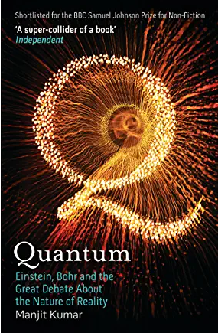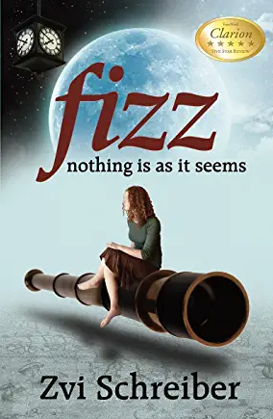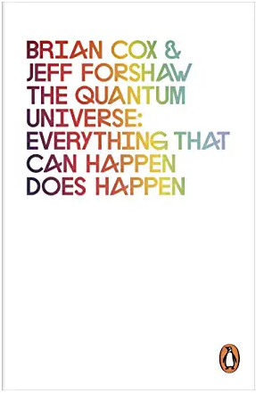

Quantum: Einstein, Bohr and the Great Debate About the Nature of Reality (Y13)

Fizz: Nothing Is as It Seems (Y11-13)

The Quantum Universe: Everything that can happen does happen (Y13)

