How to make a good flashcard
Flash cards are good for revising as they use active recall, which is training your brain to find information you’ve learned. This is a really important skill to practice as you’ll need it in your exams. When you combine flashcards with spaced repetition and active recall, you’re setting yourself up for exam success!
They can help you test yourself and you can personalise them to include the things that you struggle to remember. Here's some top tips on how to create a fun and fact-filled flashcard that will work for any subject you are revising.
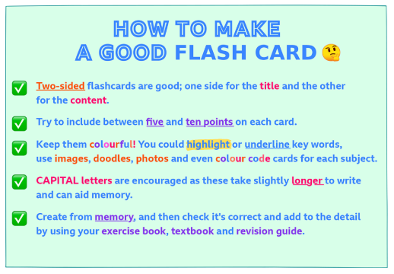

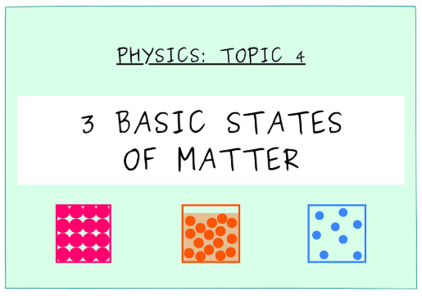
Example:
Front of flash card
Back of flash card

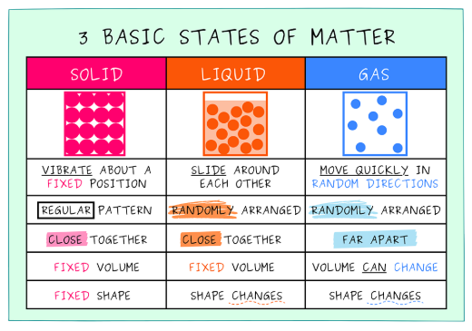

How can I use flashcards effectively?
The simplest way to use flashcards for revision is to write a question or prompt on one side and the answer on the other. But how can you upgrade your flashcards to make them even better? Here are four ways you can improve your flashcards to boost your memory.
1. Use images and colours
Using visual aids will help you make mental associations and trigger your memory. Use different coloured flashcards, pens or highlighters to differentiate between different topics in your cards and associate a certain colour with a topic.
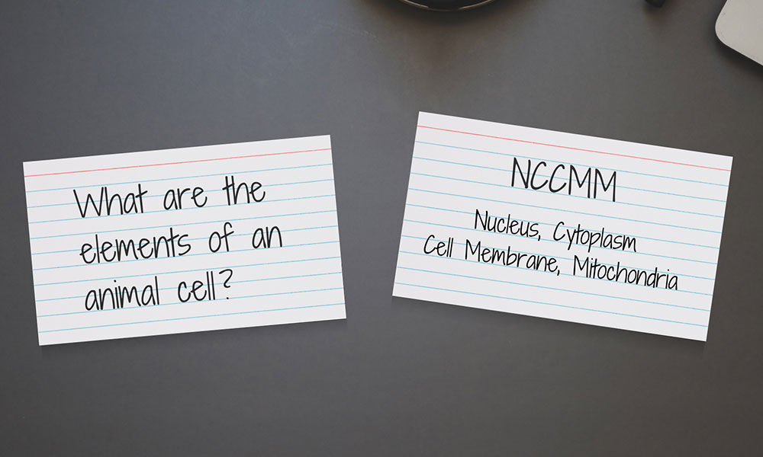
If images help you, write your notes on one side and the image on the other, so that when you see the image you remember the information.
2. Use flashcards to test yourself
Just reading the information on your cards won’t get you very far. Instead, try using active recall. Test yourself to give your memory a workout and practice the skills you’ll need in the exam.
Alternatively, ask a friend or family member to test you. Working with someone else breaks up your revision periods and makes them a little more interesting. The more interesting and engaging something is, the more likely you are to remember it.
3. Use a boxes to manage your recall strategy (the Leitner System)
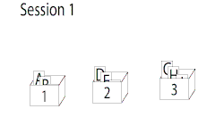
As you test yourself with flashcards you can use boxes to work out how often you need to review topics and to find your weak spots. For this you’ll need three boxes to store your cards. Cards start in box one and every time you get one right it moves to the next box. Any ones you get wrong get moved back to the first box to be reviewed more frequently until you get them right. This is a great example of spaced repetition.
The Leitner System explained:
There are 3 boxes of cards called "Box 1", "Box 2" and "Box 3". The cards in Box 1 are the ones that you often make mistakes with, Box 2 contains the cards that you rarely makes mistakes in, and Box 3 contains the cards that you know very well. You might choose to study the Box 1 cards once a day, Box 2 every 3 days, and Box 3 cards every 5 days. If you look at a card in Box 1 and get the correct answer, you "promote" it to Box 2. A correct answer with a card in Box 2 "promotes" that card to Box 3. If you make a mistake with a card in Box 2 or Box 3, it gets "demoted" to the first box, which forces you to study that card more often.
The advantage of this method is that you can focus on the most difficult flashcards, which remain in the first two boxes. The result is, ideally, a reduction in the amount of study time needed.

4. Use acronyms
On one side of your flashcard, try writing an acronym that spells out what is on the other side. For example, if your acronym was NCCMM, this would help you remember the four main elements of an animal cell: Nucleus, Cytoplasm, Cell Membrane and Mitochondria. If you put the acronym to a rhythm, like making it into a song, it might help you remember it even better.
If this is a revision technique that works for you then you can make it as complex or simple as you like, even to memorise a whole paragraph.

