Y11 GCSE Prep
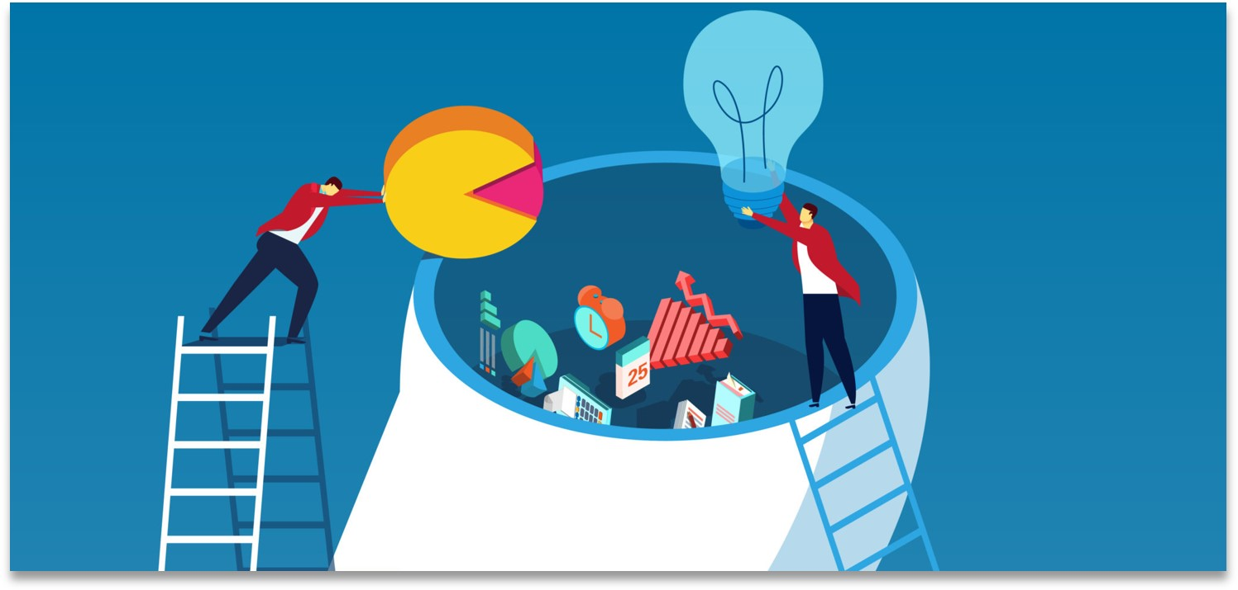
Mar-Jun 2024
Smart Learning Revision Planner

Before, During & After…
Since the introduction of the Smart Learning initiative, we have explored advice on preparing before learning, what to do during learning and how to practice retrieving and applying knowledge after you’ve learnt new material. Each of the videos invites you to make a pledge to change your learning habits for the better – write your pledges in the table below after watching each video…
Before | During | After
  Attention |   Cognitive Load |   Digital Devices
  Diet | 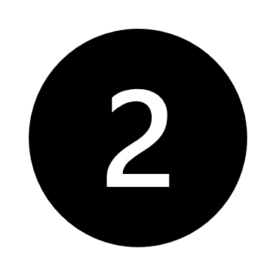  Dual Coding |   The Forgetting Curve
  Mental Wellbeing |   Elaboration |   Illusion of Mastery
  Motivation |   Flash Cards |   Interleaving
  Procrastination |   Knowledge Organisers |   Past Papers
  Reading |   Loci | 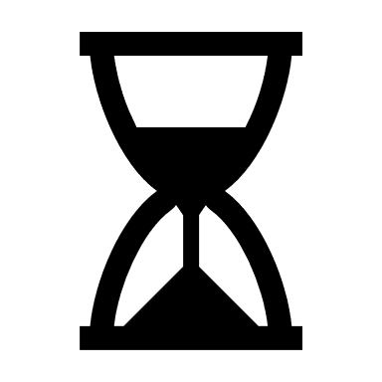  Spacing
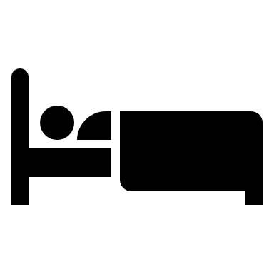  Sleep |   Teacher Feedback |   Using Revision Materials

Suggested Video: The Illusion of Mastery
Many students who underperform in assessments fall victim to this trick of the mind. Watch the video and make a pledge about how you’re going to ‘take away the scaffolding’ when doing your recall, to be honest with yourself about what you do and don’t know. My pledge is:

Interleaving and Spacing
Cramming wastes time. Not because you don’t learn anything but because you forget it quickly, so will have to do it all over again. Use the diary below to space your revision over the coming weeks. You should be starting early and practicing retrieval regularly. Use each colour to stand for a different group of subjects, swapping topics around so that you’re revising them in different orders. This is called ‘interleaving’.
Subjects and Topics:

Subjects and Topics:

Subjects and Topics:

Subjects and Topics:

Mon | Tue | Wed | Thu | Fri | Sat | Sun
Mar 25 | 26 | 27 | 28 | 29 | 30 | 31
Apr 1 | 2 | 3 | 4 | 5 | 6 | 7
8 | 9 | 10 | 11 | 12 | 13 | 14
15 | 16 | 17 | 18 | 19 | 20 | 21
22 | 23 | 24 | 25 | 26 | 27 | 28
29 | 30 | May 1 | 2 | 3 | 4 | 5
6 Bank Holiday | 7 | 8 | 9 GCSE Exams Start | 10 | 11 | 12
13 | 14 | 15 | 16 | 17 | 18 | 19
20 | 21 | 22 | 23 | 24 | 25 | 26
27 | 28 | 29 | 30 | 31 | Jun 1 | 2
3 | 4 | 5 | 6 | 7 | 8 | 9
10 | 11 | 12 | 13 | 14 | 15 | 16

