Time | Monday | Tuesday | Wednesday | Thursday | Friday | Saturday | Sunday
7.00 – 8.00
8.00 – 9.00 | School Day |     School Day | School Day | 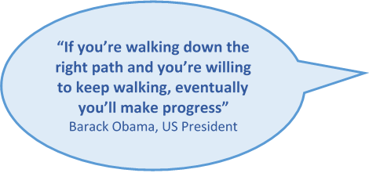  School Day |     School Day
9.00 -10.00
10.00 – 11.00
11.00 – 12.00
12.00 – 13.00
13.00 - 14.00 |  |  |  |  |  |  | 
14.00 – 15.00
15.00 -16.00
16.00 – 17.00 |  |  |  |  |  |  | 
16.00 – 17.00 |  |  |  | 
17.00 – 18.00

18.00 – 19.00
18.00 – 19.00 |  |  |  |  | 
19.00 – 20.00 |  | 
20.00 – 21.00

21.00 -22.00
 |  |  |  |  |  |  | 
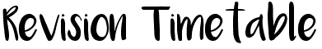


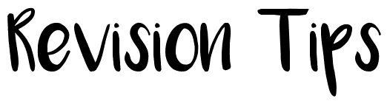

Using the revision timetable opposite insert a minimum of 2 hours revision per day (6 x 20 minute sessions). Each hour block is split into 3x 20 minute sessions in which you should allocate time evenly for all of your subjects. Remember to build in adequate rest periods as this is important time in which you will reflect on the previous sessions learning. Pin this timetable up in a convenient location in your home so that your parents are aware of the time you are allocating to revision – this may save arguments in the long run! Also, don’t forget to sign up to afterschool study support/revision sessions with your teachers, every little bit extra you put in helps – we call this marginal gains. Here is a list of revision strategies you could use but remember not every method suits everybody and more revision techniques do exist so it’s important to find the right method for you!

Take out an exercise book or revision guide and turn to a topic you need to learn. Create a mind map to help you learn the information again. Start by adding a bold title in the middle.
Mind Mapping
- Vary the Colour.
- Structure = clear and radiant.
- Include images and drawings.
- Wording – key words, SIZE & style of writing (BIG, smaller etc...)
- Lines = Thick to thin / length = length of word or image
- 1 word per line = spark your memory into life / association
- Paper = A1 TO A5 = landscape, blank, colour – you decide.
Make it PERSONAL!!
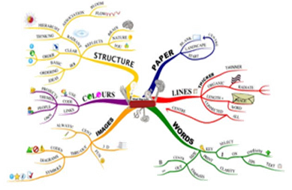
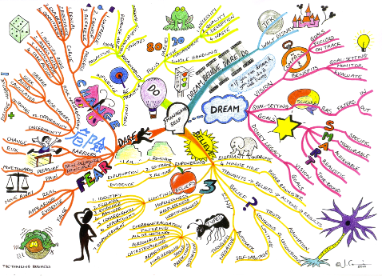

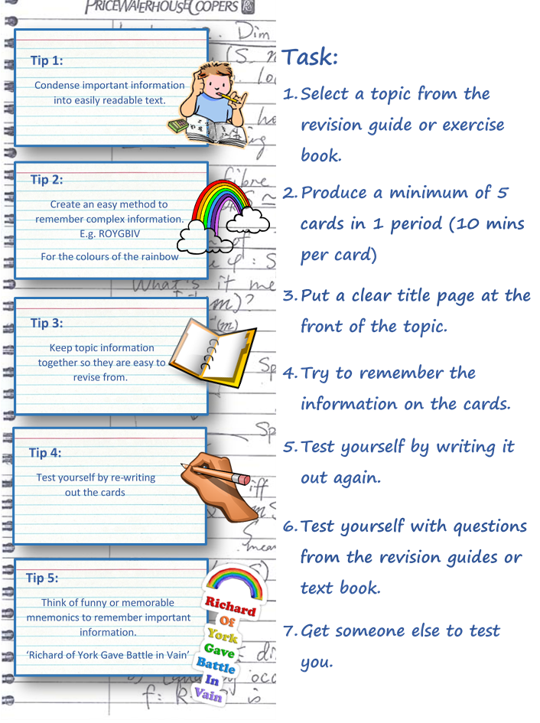

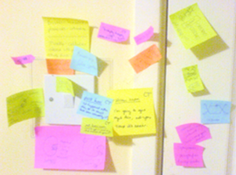

Post-it Notes

- Write facts and information on to post it notes.
- Stick them on your desk in random order.
- Turn away – how many can you memorise?
- Now put them in rank order- which is most important.
- Now arrange them in a pattern on your desk.
- Now draw pictures on your post-it notes.
- Turn away – write down as many facts as you can remember.
- How successful were you at remembering these facts?
Try sticking them on your fridge or next to light switches at home.




Mnemonics
Mnemonics help you to remember by using short words that stand for something to help you. Here is a Mnemonic for remembering the colours of the rainbow.



Chunking is breaking up a big piece of information into smaller chunks rather like steps in a ladder. It can be used for numbers and words. Often students use bullet points to break up information.
Try to remember this by breaking it up into chunks:
The average person can take in four numbers or words at a time, can concentrate on revision for a maximum of 45 minutes at a time and remembers information best shortly before bedtime.

