Assessment Framework: History

Because the knowledge structure in history looks like this:

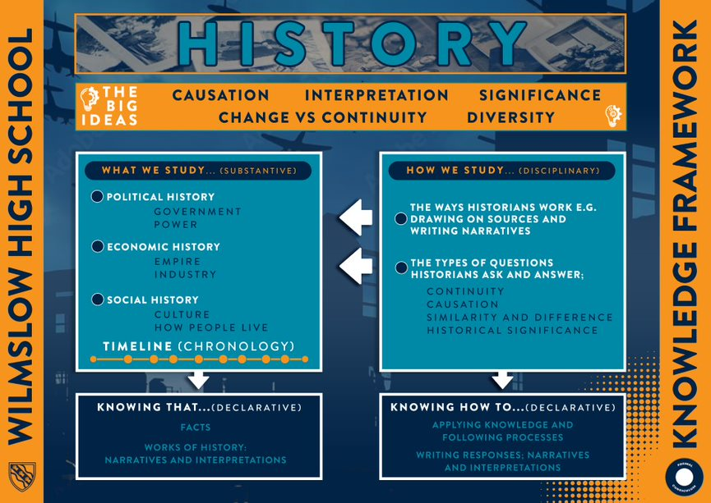

We assess both declarative and procedural knowledge from a collection of units – there are 4-6 units per year. The final unit is usually taught after the end of year exam.

This grid below outlines the formal, teacher marked, assessments that will produce a gap analysis document for each student.
 | HT1 | HT2 | HT3 | HT4 | HT5 | HT6
Year 7 – Declarative | Unit 1: Chronology, evidence, the people who shaped Britain | Unit 2: The Normans: Battle of Hastings; how the Normans took control of England including terror, castles, Domesday book and Feudal system | Unit 3: Medieval Life: Village and town life; the medieval church; women; law and order; changes made by the Normans. |  | Unit 4: Medieval England: Power and the People: Thomas Becket, Magna Carta, King Edward I, Black Death, Peasants’ Revolt, Wars of the Roses | Synoptic exam on previous work covered and Unit 5: The Tudors. Henry VII, Henry VIII – wives, Reformation, Dissolution, Edward VI, Mary I, Elizabeth I – issue of marriage, Mary Queen of Scots, Spanish Armada
Year 7 - Procedural | Utility question (how useful is a source) | Essay on why the Norman Conquest was so successful | Utility question (how useful is a source) |  | Question on the significance of an event.  Question describing the causes of an event | Range of questions including utility, causation, explanation of significance.
Year 8 – Declarative | Unit 1: The Stuarts: James I, Gunpowder Plot, causes and course of Civil War, execution of Charles I | Unit 2: The Stuarts part 2: Cromwell, Restoration, Plague, Great Fire of London, Glorious Revolution and the making of the UK |  | Unit 3: Industrial Revolution part 1: Population growth, power, agricultural changes, transport revolution, living conditions, Great Reform Act |  | Synoptic exam on previous work covered and Unit 4: The British Empire and the slave trade. Transatlantic slave trade and case studies of countries within the British Empire
Year 8 - Procedural | Essay on the causes of the Civil War | Comparison questions – focus on similarities; interpretations question. |  | Utility question (How useful is a source), explanation of problems. |  | Explanation of causes and consequences of events; comparison question; interpretations and utility questions.
Year 9 – Declarative |  | Unit 1: Britain 1900-20: First World War including Home Front; voting reform | Unit 2: 1920’s America: cycle of prosperity, immigration, isolationism, social change, Hollywood, prohibition, black Americans experiences, Wall Street Crash, Depression and New Deal | Unit 3: Nazi Germany: Hitler’s rise to power, life in Nazi Germany, experience for young people, Experiences of Jewish people, Hitler’s foreign policy and appeasement |  | Synoptic exam on previous work covered and Unit 4: Second World War: Dunkirk, Battle of Britain, Blitz, evacuation, home front, Russia, D-Day, Dresden and atomic bomb.
Year 9 - Procedural |  | Utility question (how useful is a source); explanation of changes made during the period. | Essay: Does the ‘Roaring Twenties’ deserve it’s title? | Utility question (how useful is a source); consequences of Nazi rule. |  | Explanation of problems / changes; explanations of causes and effects of events; utility question.

Assessment Cycle in History
Type | Length | Focus | Impact | Team Strategies
Short-cycle | Lesson to lesson | - Within lessons and between lessons (marking) - ongoing assessment to check students’ understanding through a unit of work.  - It also helps teachers be more responsive to students’ needs and adjust delivery when appropriate | - Increased student engagement and understanding  - Improve teacher responsiveness. | - Retrieval starters  - Starter and plenary exercises  - Exit tickets  - 100% response through Q & A / white boards.  - Strategic questioning  - Traffic lights to indicate understanding
Medium-cycle | KS3 - End of each unit : Four to six weeks | - At the end of teaching units to find out what students know.  - Declarative and procedural testing with multiple skills and knowledge being tested.  - Shows students you value their previous learning. | - Improved student involvement in their assessment  - improved teacher understanding about learning | - KS3 end of unit assessments.  - KS3 Individual pieces of assessed work.  - KS4- Assessed H/W e.g. extended writing, annotated images. (weekly / fortnightly)  - KS4 and KS5 End of unit tests  KS5- Exam questions and essays
Long-cycle | Bi-annual | - Teacher judgements on progress, informs data captures . | - Improved student monitoring  - Informs curriculum development | - Summative 1 and 2 assessment points fixed in calendar.

