A level Business Assessment Framework
What skills are tested?
Knowledge
Application
Analysis
Evaluation
How are the skills examined?
There are three examination papers:
Paper one
- Written exam covering all content
- 2 hours
- 100 marks
- 33.3% of A-level
- Short & long answer questions
Paper two
- Written exam covering all content
- 2 hours
- 100 marks
- 33.3% of A-level
- Three data response sections
Paper three
- Written exam covering all content
- 2 hours
- 100 marks
- 33.3% of A-level
- One case study with 6 questions

Because the knowledge structure in business looks like this:

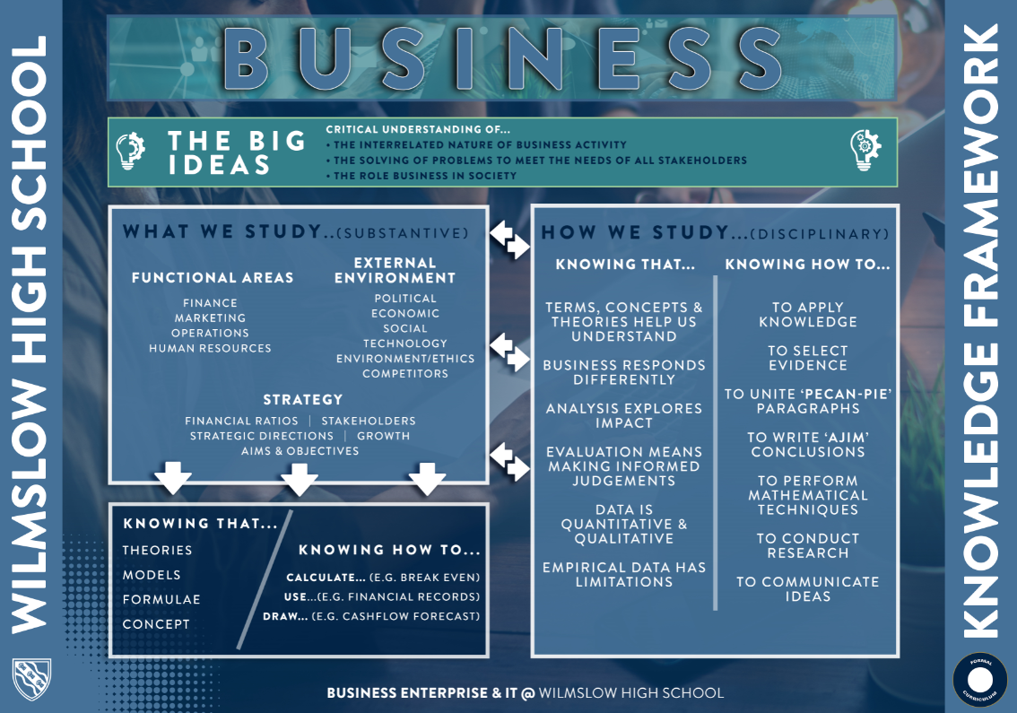
Short cycle
Each lesson begins with a low-stakes knowledge retrieval activity in the form of a “5-a-day quiz”. This task assesses the students’ recall of previously taught knowledge. Plenaries are used throughout lessons as a form of formative assessment to gauge the pupils’ understanding of the content and to provide us with immediate feedback on progress and potential misconceptions. We also utilize various questioning strategies such as “cold calling” and “hinge questions” in order to gain an insight into how well the pupils are learning the new content. We frequently use examination-style questions in order to challenge the pupils’ procedural knowledge and application of the content that they have been taught.
Medium cycle
So as to avoid “Construct Irrelevant Variance”, there will be frequent knowledge quizzes, key terms quizzes, and essays completed during each term. The variety of assessment methods will aid us in determining where the misconceptions of the pupils lie. As well as consolidating declarative knowledge, essays will also be used to assess the procedural knowledge of the pupils and an entire lesson will be dedicated to this purpose. Students will be set a piece of homework prior to the ‘essay lesson’ to prepare an essay plan. Essays will all be written into an ‘essay book’, which will stay in school and will shows the students’ progress against the assessment objectives. These assessment methods are sequenced in a specific order to aid knowledge recall through spaced retrieval.
Long cycle
The pupils will complete end of unit assessments and mock examinations throughout years 12 and 13. The data obtained from these tests will provide us with an overview of how the pupil is performing and how they fare in examination conditions. The assessments will comprise of past paper examination-style questions so they will test both the procedural knowledge and declarative knowledge of the pupils.
Year 12
 | Half Term 1 | Half Term 2 | Half Term 3 | Half Term 4 | Half Term 5 | Half Term 6
Year 12  Teacher 1 - Procedural |  | Progress test  - Mission & objectives  - Profit  - Ownership  - Shares & market cap  - External influences | Mock  - What is Business  - Marketing | Progress test  - Marketing objectives  - Market research  - Market data  - PED/YED  - Marketing mix | Progress test  - Operational data  - Lean production  - Mix of resources | Mock  - Unit 1  - Unit 2  - Unit 3
Year 12  Teacher 1 - Procedural | Essay  - Real Smoothies – objectives  - Horbury – ownership  - Loris – external factors | Essay  - That Entertainment – market research  - PED | Essay  - Morrisons – STP  - New Frontiers – product | Essay  - Maruti – Price  - Lindley Dairies – operational data | Essay  British Classic Cars – labour productivity | Essay  Passion for fashion - quality
Year 12  Teacher 1 – Declarative | - Key terms/knowledge tests  - Essay prep | - Key terms/knowledge tests  - Essay prep | - Key terms/knowledge tests  - Essay prep | - Key terms/knowledge tests  - Essay prep | - Key terms/knowledge tests  - Essay prep | - Key terms/knowledge tests  - Essay prep
Year 12  Teacher 2 – Procedural | Pre-test Numeracy  Essay  - Perfect Pooch –financial objectives  - Netherwell Parcels – Breakeven  - I Do Wedding Photography - Budgeting | Progress test  - Financial objectives  - Breakeven – calculation and diagrams  - Budgeting  - Cashflow  - How to improve profitability  Essay  - Pay Later PLC – Cashflow  - Prickly PLC – Improving Profitabilty  - Out and About – Financial sources | Mock  - Financial Decision-making (U5)  Essay  - Perfect Paper – leadership and management  - Appleton Farm – Decision trees | Progress test  - Leadership & management  - Decision trees  - Stakeholders  Essay  - Roxio PLC – Stakeholders  - Perfect Pottery – HR Objectives | Progress test  - HR objectives  - Engagement and motivation  - Organisation and Job design  - Employer/ Employee relations  - Analysing HR performance  Essay  - Simply You is Proftable – Motivation  - Cut Costs – organisational design and HR objectives | Mock  - Unit 5  - Unit 2  - Unit 6  Essay  - Connect – employer/employee relations  - Europark (yr 13 topic)
Year 12  Teacher 2 – Declarative | - Key terms/knowledge tests  - Essay prep | - Key terms/knowledge tests  - Essay prep | - Key terms/knowledge tests  - Essay prep | - Key terms/knowledge tests  - Essay prep | - Key terms/knowledge tests  - Essay prep | - Key terms/knowledge tests  - Essay prep

Year 13
 | Half Term 1 | Half Term 2 | Half Term 3 | Half Term 4 | Half Term 5
Year 13  Teacher 1 - Procedural | Mock Resit  Unit 1, 3 & 4  Essay  - John Lewis -SWOT  - New Zealand – Zero hour contracts  - Legislation questions  - Exchange rate question | Mock  Unit 1, 3, 4 & 7  Essay  - Economic environment question  - Berry Delights – globalization  - Jamie’s Garden – CSR  - 25p store - Competition | Progress test  Unit 8  Essay  - Euroair – Ansoff Matrix  - Frozen World – Strategic direction  - Flexible organization question  - Culture question | Progress test  Unit 10  Essay  - 24 & 25 mark practice | Progress test  Essay
Year 13  Teacher 1 - Declarative | - Key terms/knowledge tests  - Essay prep | - Key terms/knowledge tests  - Essay prep | - Key terms/knowledge tests  - Essay prep | - Key terms/knowledge tests  - Essay prep | - Key terms/knowledge tests  - Essay prep
Year 13  Teacher 2 - Procedural | Mock resit  Unit 2,5 & 6  Essay  - Home Start – profitability & liquidity ratios  - Savoir Beds – Effirciency ratios  - Riviera Fine Dining – consolidation ratios | Mock Unit 2,5,6,7  Essay  - Kim Group – growth  - Lex – Retrenchment  - Innovation at Bricks – Innovation | Progress test  Unit 9  Essay  - Lo-Co – Digital tech  - Off-Shoring at Myson – Internationalisation  - Shelley’s Boutique – Network Analysis  - Sports R Us | Progress test  Number work  Essay  24 & 25 marks questions | Progress test  Essay
Year 13  Teacher 2 - Declarative | - Key terms/knowledge tests  - Essay prep | - Key terms/knowledge tests  - Essay prep | - Key terms/knowledge tests  - Essay prep | - Key terms/knowledge tests  - Essay prep | - Key terms/knowledge tests  - Essay prep

