

AQA
GCSE Biology
New Unit 1
Summary Notes

B1.1 Keeping Healthy
B1.1.1 Diet and Exercise

Summary
A combination of a balanced diet and regular exercise is needed to help keep the body healthy.

Healthy Diet
- A healthy diet contains the right balance of the different foods you need and the right amount of energy.
- These foods should provide the following nutrient groups:
  - Carbohydrates for energy and to make cell structures
  - Fat for energy and insulation and cell structures
  - Protein to control cell reactions (as enzymes) and to build cell structures
  - Vitamins and minerals to help our bodies function well.

Malnourishment
- A person is malnourished if their diet is not balanced.
- This may lead to a person being overweight or underweight.
- An unbalanced diet may also lead to diseases.
- Lack of essential nutrients in the diet can lead to deficiency diseases.
- Excess intake of high energy foods can lead to type 2 diabetes.
  - This is a disease where the person is unable to control the levels of sugar in their blood.
  - This is very dangerous, and the person must carefully control their diet and monitor their blood sugar levels regularly.

Slimming programmes
- A person gains mass when the energy content of the food taken in is more than the amount of energy expended by the body.
- A person loses mass when the energy content of the food taken in is less than the amount of energy expended by the body.
- An effective slimming programme advises people to reduce the energy content of their food, and to increase the amount they exercise.
- Some slimming programmes encourage people to consume a low proportion of one of the nutrient groups in their diet. This may enable them to lose weight, but it will not necessarily be a sensible, healthy diet.

Exercise
- Exercise increases the amount of energy expended by the body.
- People who exercise regularly are usually healthier than people who take little exercise.
- They expend more energy and their circulatory system becomes more efficient.
- They are likely to have lower blood pressure, and less likely to be overweight.

Metabolic rate
- This is the rate at which all the chemical reactions in the cells of the body are carried out.
- One major set of metabolic reactions is respiration.
- The rate of these reactions vary with the amount of activity you do.
- The more activity, the more energy is required by the body.
- Metabolic rate also varies with respect to the proportion of muscle to fat in your body.
- The higher the proportion of muscle to fat, the higher the metabolic rate.
- Exercise increases the proportion of muscle to fat.

Inheritance
- Inherited factors can influence our health.
- We can inherit genes from our parents which can influence our metabolic rate.
- We can also inherit genes which influence our cholesterol level.
- Cholesterol is a substance that our body creates from fat that we consume in our diet.
- Cholesterol is needed to make cell membranes.
- However, too much cholesterol can increase the chance of cardio-vascular diseases, such as strokes, heart attacks and thrombosis.

B 1.1.2 Infectious Disease

Summary
Our bodies provide an excellent environment for many microbes which can make us ill once they are inside us. Our bodies need to stop most microbes getting in and deal with any microbes which do get in. Vaccination can be used to prevent infection.

Pathogens
- Microorganisms that cause infectious disease are called pathogens.
- Disease occurs when large numbers of pathogenic micro-organisms enter the body.

Bacteria
- Not all bacteria are pathogens.
- Pathogenic bacteria reproduce rapidly inside the body and may produce poisons (toxins) which make us feel ill.
- Example: E.coli produces toxins that cause fever symptoms when we have food poisoning.

Viruses
- Viruses are much smaller than bacteria.
- All viruses are pathogens.
- Viruses also produce toxins and they damage the cells in which they reproduce, leading to illness.
- Viruses replicate by invading cells, reproducing inside them and bursting them.
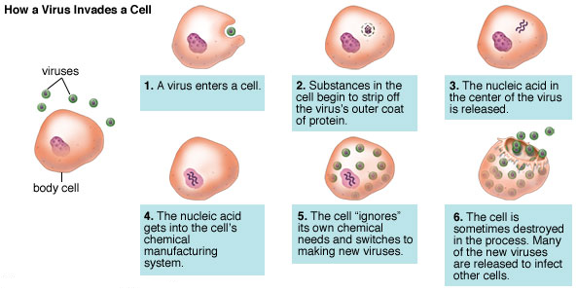
- This causes damage to tissues, leading to illness.

- Examples:
  - HIV damages white blood cells, reducing immunity and leading to AIDS.
  - Influenza virus released toxins which cause aches and fever symptoms.

The immune system
- The body has different ways of protecting itself against pathogens.
- White blood cells defend our internal environment from pathogens
- These form part of our immune system.
- There are various types of white blood cells:
  - Cells that ingest and destroy microorganisms

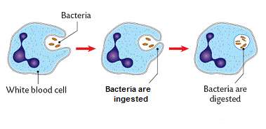
- Cells that produce antitoxins that destroy toxins released by pathogens
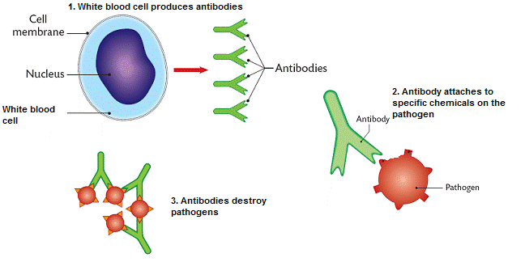
- Cells that produce antibodies that destroy specific pathogens:
  - They produce specific antibodies to kill a particular pathogen.
  - This leads to immunity from that pathogen.
  - The body is able to rapidly produce large numbers of the specific antibodies if it is exposed to the same pathogen in the future.
  - In some cases, dead or inactivated pathogens stimulate antibody production.
  - This also leads to immunity.

Preventing transmission
- In the 1850s Semmelweiss recognised the importance of hand-washing in the prevention of spreading some infectious diseases.
- He insisted that medical students washed their hands before delivering babies.
- This resulted in doctors washing their hands before and after examining patients.
- This greatly reduced the number of deaths from infectious diseases in his hospital.
- This idea was not readily accepted – people were not aware of microorganisms.
- Nowadays, it is standard practice for people to wash hands after treating patients, to prevent disease being transmitted to other patients.

Using drugs to treat disease
- Some medicines, including painkillers, help to relieve the symptoms of infectious disease, but do not kill the pathogens.
- Antibiotics are medicines that help to cure bacterial disease by killing infective bacteria inside the body. Eg penicillin
- Antibiotics cannot be used to kill viral pathogens, which live and reproduce inside cells.
- It is difficult to develop drugs which kill viruses without also damaging the body’s tissues.
- It is important that specific bacteria should be treated by specific antibiotics.
- Antibiotics kill bacteria inside the body.
- The use of antibiotics has greatly reduced deaths from infectious bacterial diseases.

Antibiotic resistance
- Overuse and inappropriate use of antibiotics has increased the rate of development of antibiotic resistant strains of bacteria.
- Pathogenic bacteria mutate, producing resistant strains.
- Antibiotics kill individual pathogens of the non-resistant strain.
- Individual resistant pathogens survive and reproduce, so the population of the resistant strain increases.
- Antibiotics and vaccinations may no longer be effective against a new resistant strain of the pathogen.
- The new strain will then spread rapidly because people are not immune to it and there is no effective treatment.
- Many strains of bacteria, including MRSA, have developed resistance to antibiotics as a result of natural selection.
- These bacteria can enter the body through wounds and cuts.
- Healthy people’s white blood cells would quickly destroy these bacteria.
- People who are ill in hospital are likely to have reduced immunity to bacterial disease, and become infected more easily.

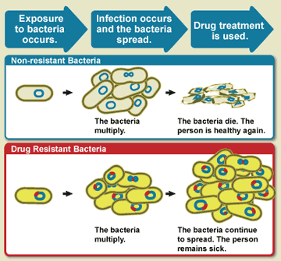
What can be done?
- Doctor’s should only prescribe antibiotics when necessary – and not for viruses.
- It is important that if you are prescribed antibiotics you take the whole course.
  - A lot of people will stop taking the antibiotic when they feel better.
  - If you do this, you leave a few bacteria inside your body.
  - These will reproduce, increasing the chance of some developing resistance.
- Scientists are trying to develop new versions of the antibiotics.
- Some antibiotics are developed but not used – just in case.

Epidemics and Pandemics
- Epidemics – diseases that spread widely through one country.
- Pandemics – diseases that spread through several countries.

Eg Influenza
- A viral disease.
- Most people recover in a week.
- People who are old or very young or already ill can die.
- Different strains of influenza affect other animals.
- These rarely affect humans, because humans need to directly contact an infected animal.
- Humans that are infected may be more likely to die than if they had human influenza.
- Most of these viruses cannot be transmitted from human to human.
- However, there are concerns that the viruses could mutate and become able to be transmitted between humans.
- If it does this, it will start off by causing an epidemic, which may spread to become a pandemic.
- Many people could die, particularly very old people, very young people, and people who are already ill.

Immunisation
- If a large proportion of the population is immune to a pathogen, the spread of the pathogen is very much reduced.
- Eg small pox was completely eradicated by the 1970s.
- People can be immunised against a disease by introducing small quantities of dead or inactive forms of the pathogen into the body (vaccination).
- Vaccines stimulate the white blood cells to produce antibodies that destroy the pathogens.
- This makes the person immune to future infections by the microorganism.
- The body can respond by rapidly making the correct antibody, in the same way as if the person had previously had the disease.
- An example is the MMR vaccine used to protect children against measles, mumps and rubella.

Growing Microoganisms
- Microorganisms = organisms that can only be viewed with a microscope.
- Eg bacteria, viruses and fungi.
- Uncontaminated cultures of microorganisms are required for investigating the action of disinfectants and antibiotics.
- It is important that the culture is not contaminated with other microorganisms that may compete for nutrients or produce toxins.
- Careful procedures are required to prevent potentially pathogenic microorganisms being released into the environment.

Culturing microorganisms
- To study microorganisms, they need to be cultured.
- They need to be provided with the conditions they need to reproduce quickly:
  - Nutrients
  - Warmth
  - Moisture
- Bacteria and fungi can be grown in special media called agar.
- This provides them with:
  - Carbohydrate
  - Protein or amino acids
  - Water
- When agar is heated up it is liquid.
- It can be poured into a Petri dish.
  - A circular plastic or glass dish with a lid:

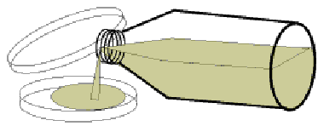

- The agar solidifies when left to cool.
- Petri dishes and culture media must be sterilised before use to kill unwanted microorganisms
- Inoculating loops are used to transfer microorganisms to the media.
- These must be sterilised by passing them through a flame:
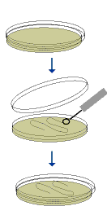

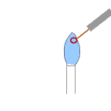

- The lid of the Petri dish should be secured with adhesive tape to prevent microorganisms from the air contaminating the culture.

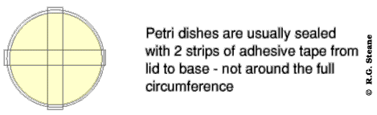

- In school and college laboratories, cultures should be incubated at a maximum temperature of 25ºC.
- This greatly reduces the likelihood of growth of pathogens that might be harmful to humans.
- In industrial conditions higher temperatures can produce more rapid growth.

B1.2 Nerves and Hormones

Summary
The nervous system and hormones enable us to respond to external changes. They also help us to control conditions inside our bodies. Hormones are used in some forms of contraception and in fertility treatments. Plants also produce hormones and respond to external stimuli.

The nervous system
- The nervous system enables humans to react to their surroundings and coordinate their behaviour.
- Central nervous system = brain plus spinal cord.
- Stimuli = changes in the environment.
- Receptors = cells that detect stimuli
- Nerve impulse = electrical message that passes along a neurone.
- Neurones = nerve cells.

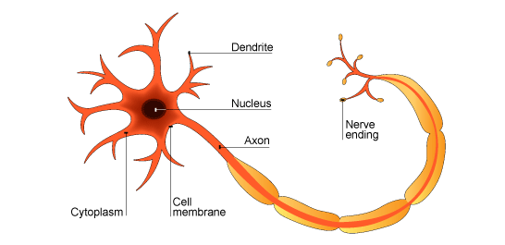
- Neurones are highly specialised cells:
  - Very long so nerve impulses can travel quickly to different parts of the body.
  - Branched ends to form connections with many other neurones.
  - Insulating sheath to maintain the nerve impulse.
- Nerve = a bundle of neurones connected to brain or spinal cord.
- Sensory neurone = nerve cell that transmits nerve impulse from a receptor to the central nervous system.
- Relay neurone = neurone in the central nervous system.
- Motor neurone = nerve cell that transmits nerve impulse from the central nervous system to an effector.
- Effector = a structure that the nervous system causes to respond – a muscle or gland.

Synapses
- Synapses = junctions between nerve cells.
- When a nerve impulse arrives at the end of a neurone, chemicals are released.
- These diffuse across the synapse, and cause a new nerve impulse in the next neurone.

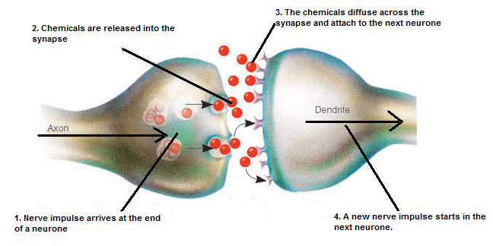

Receptors
- Receptors and the stimuli they detect include:
  - receptors in the eyes that are sensitive to light
  - receptors in the ears that are sensitive to sound
  - receptors in the ears that are sensitive to changes in position and enable us to keep our balance
  - receptors on the tongue and in the nose that are sensitive to chemicals and enable us to taste and to smell
  - receptors in the skin that are sensitive to touch, pressure, pain and to temperature changes.
- Light receptor cells, like most animal cells, have a nucleus, cytoplasm and cell membrane.
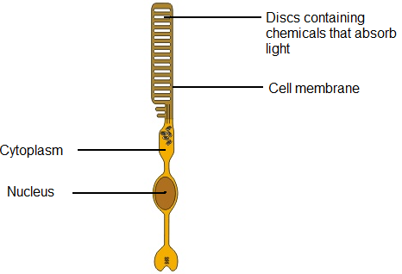
- Information from receptors passes along neurones in nerves to the spinal cord and the brain.
- The brain coordinates the response.
Reflex actions
- Reflex actions are automatic and rapid.
- They are simple responses to stimuli that often protect the body from harm.
- They often involve sensory, relay and motor neurones.
- The pathway starting with a stimulus and resulting in a response does not require conscious control by the brain.
- In a simple reflex action:
  - Impulses from a receptor pass long a sensory neurone to the central nervous system
  - There is a synapse between a sensory neurone and a relay neurone in the central nervous system
  - A chemical is released at the synapse between the sensory neurone and a relay neurone.
  - This causes an impulse to be sent along the relay neurone
  - A chemical is then released at the synapse between a relay neurone and motor neurone in the central nervous system
  - This causes impulses to be sent along a motor neurone to the effector
  - This is either a muscle or a gland
  - A muscle responds by contracting
  - A gland responds by releasing (secreting) chemical substances eg salivary gland releases saliva.

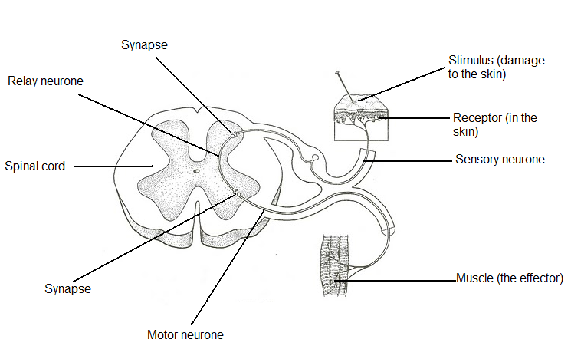

Control in the human body
- Internal conditions that are controlled include:
  - The water content of the body:
    - Water leaves the body:
      - via the lungs when we breathe out
      - via the skin when we sweat to cool us down.
    - Excess water is lost via the kidneys in the urine
  - The ion content of the body:
    - Ions are lost via the skin when we sweat
    - Excess ions are lost via the kidneys in the urine
  - Temperature:
    - To maintain the temperature at which enzymes work best.
    - Enzymes are protein molecules that control reactions inside and outside cells.
    - They are sensitive to changes in temperature and work best at body temperature – 37ºC.
  - Blood sugar levels:
    - To provide the cells with a constant supply of energy.
    - We take in sugars as carbohydrate in our food.

Hormones
- Many processes within the body are coordinated by chemical substances called hormones.
- Hormones are secreted by glands.
- They are transported to their target organs by the bloodstream.
- Hormones regulate the functions of many organs and cells.

Menstrual cycle
- The monthly release of an egg from a woman’s ovaries
- The changes in the thickness of the lining of her womb
- These are controlled by hormones secreted by the pituitary gland and by the ovaries.
- They are involved in promoting the release of an egg.
- Follicle stimulating hormone (FSH):
  - Secreted by the pituitary gland
  - Causes eggs to mature in the ovaries.
  - It also stimulates the ovaries to produce hormones including oestrogen.
- Oestrogen:
  - Secreted by the ovaries.
  - Inhibits the further production of FSH.
  - Brings about the release of LH.
- Luteinising hormone (LH):
  - Stimulates the release of eggs from the ovary
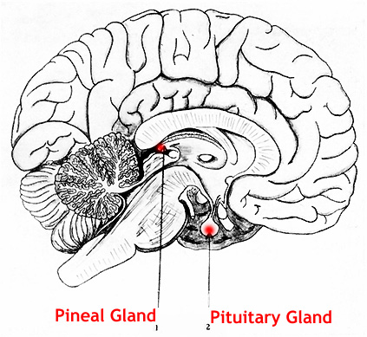 5. Oestrogen causes
4. Oestrogen inhibits 1. FSH released release of LH from
production of FSH from pituitary pituitary

Oestrogen FSH LH

2. Causes egg to mature
In ovary

3. Causes release of oestrogen by ovary 6. LH causes release
of an egg from the ovary
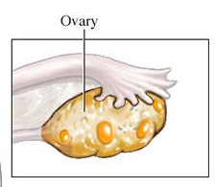

The use of artificial fertility controlling hormones
- Hormones can be synthesised artificially.
- These are very similar to human hormones, and can be used to affect the way the body works.
- Some people are concerned about the use of hormones that control fertility.

Oral contraceptives:
- Oral contraceptives contain hormones to inhibit FSH production so that no eggs mature.
- Oral contraceptives may contain oestrogen and progesterone to inhibit egg maturation.
- The first birth-control pills contained large amounts of oestrogen.
- These resulted in women suffering significant side effects
- Progesterone-only pills lead to fewer side effects.
- Birth-control pills now contain a much lower dose of oestrogen, or are progesterone only.
- Some religions do not encourage the use of hormones that prevent conception.

Fertility drugs
- Fertility drugs can be given to women whose own level of FSH is too low to stimulate eggs to mature.
- They contain FSH and LH.
- This stimulates eggs to mature.
- This increases the chances of getting pregnant.
- These drugs are also used in in-vitro fertilisation (IVF) treatment.
- IVF involves giving a mother FSH and LH to stimulate the maturation of several eggs.
- The eggs are collected from the mother and fertilised by sperm from the father.
- The fertilised eggs develop into embryos.
- At the stage when they are tiny balls of cells, one or two embryos are inserted into the mother’s uterus (womb).
- Some people believe that the human population is growing too quickly anyway.
- Fertility drugs can result in multiple pregnancies, which can be dangerous to the mother.
- Excess embryos may be used for embryo research, and many people disagree with this, because embryos have the potential to become a living human.

Control in plants
- Plants are sensitive to light, moisture and gravity:
- Their shoots grow:
  - towards light
  - against the force of gravity
- Their roots grow:
  - towards moisture
  - in the direction of the force of gravity.
- Plants produce hormones to coordinate and control growth.
- Auxin controls phototropism and gravitropism (also called geotropism).
- The responses of plant roots and shoots to light, gravity and moisture are the result of unequal distribution of hormones, causing unequal growth rates.

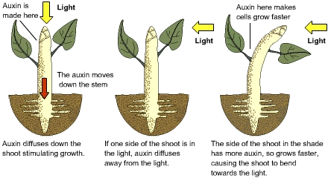
- The auxin diffuses away from the stimulus.
- It affects the growth of cells in different ways.
- In the shoots:
  - It causes increased cell growth
  - This causes the shoot to curve towards the stimulus.
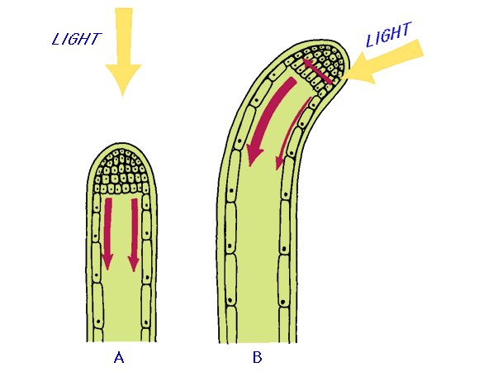
- In the roots:
  - It inhibits cell growth.
  - This causes the root to curve away from the stimulus.

The use of artificial plant hormones
- Plant growth hormones are used in agriculture and horticulture.
- Agriculture = large scale business involving cultivating of soil, to produce crops, and raise livestock.
- Horticulture = small scale cultivation of fruits, vegetables, flowers, or ornamental plants typically in a garden.
- Chemicals are synthesised that are similar to plant hormones.
- Some people are concerned about these chemicals entering the food chain and causing toxic effects.

Weed killers
- Chemicals that are used that are specific to the weeds eg dandelions.
- They cause the weed to grow very quickly.
- The weed cannot sustain this rate of growth and dies.
- This also kills other wild plant species that are not weeds.

Rooting hormones
- Cuttings are taken from a plant.
- The cutting is dipped into rooting powders.
- The hormone causes cells in the cutting to develop into roots.

B1.3 The Use and Abuse of Drugs

Summary
Drugs affect our body chemistry. Medical drugs are developed and tested before being used to relieve illness or disease. Drugs may also be used recreationally as people like the effect on the body. Some drugs are addictive. Some athletes take drugs to improve performance. People cannot make sensible decisions about drugs unless they know their full effects.

Types of drugs
- Medical drugs:
  - Prescribed – a doctor must provide a prescription for these to be obtained.
    - Eg antibiotics and strong pain killers such as morphine.
  - Non-prescribed – these can be bought in a chemist without a prescription.
    - Eg pain killers such as aspirin and paracetomol, and cough medicine.
- Recreational drugs:
  - Legal – eg alcohol, caffeine, nicotine
  - Illegal – eg ecstasy, cannabis and heroin

Drug trials
- Scientists are continually developing new drugs.
- When new medical drugs are devised, they have to be extensively tested and trialled before being used.
- Drugs are tested in a series of stages to find out if they are safe and effective.
- New drugs are extensively tested for toxicity, efficacy and dose:
  - in the laboratory, using cells, tissues and live animals
  - in clinical trials involving healthy volunteers and patients.
    - Very low doses of the drug are given at the start of the clinical trial.
    - If the drug is found to be safe, further clinical trials are carried out to find the optimum dose for the drug.
    - In some double blind trials, some patients are given a placebo, which does not contain the drug.
    - Neither the doctors nor the patients know who has received a placebo and who has received the drug until the trial is complete.

Thalidomide
- Thalidomide is a drug that was developed as a sleeping pill.
- It was also found to be effective in relieving morning sickness in pregnant women.
- Thalidomide had not been tested for this use.
- Unfortunately, many babies born to mothers who took the drug were born with severe limb abnormalities.
- The drug was then banned.
- As a result, drug testing has become much more rigorous.
- More recently, thalidomide has been used successfully in the treatment of leprosy and other diseases.

Statins
- Statins are a relatively new group of drugs used to lower blood cholesterol levels.
- A high cholesterol level increases a person's risk of having a heart attack or stroke.
- The long-term use of statins reduces the risk of such an event and can increase the life expectancy of people with a history of heart disease.
- People are concerned that these drugs could encourage people to lead an unhealthy lifestyle in the belief that they can reduce their cholesterol levels.

Drug Abuse
- Some people use drugs recreationally.
- Some of these recreational drugs are more harmful than others.
- Some of these drugs are legal, such as alcohol and nicotine.
- Some of these drugs are illegal such as ecstasy, cannabis and heroine.
- Some of these drugs are prescribed but are not taken sensibly, such as sleeping tablets, antidepressants and strong pain killers such as morphine.
- The overall impact of legal drugs on health is much greater than the impact of illegal drugs, because far more people use them.

Addiction and Withdrawal
- Drugs change the chemical processes in people’s bodies.
- Drugs work by affecting synapses.
- Some drugs make them work faster (eg, caffeine).
- Some drugs make them work slower (eg. cannabis).
- Drug abusers may become dependent or addicted to the drugs.
- They may suffer withdrawal symptoms without them.
- Heroin and cocaine are very addictive.
- There are concerns about the possible progression from people taking non-addictive recreational drugs to addiction to hard drugs.
- For example, cannabis is referred to as a gateway drug; it is thought that it leads to people taking cocaine or heroin.

Effects of drugs
- Alcohol affects the nervous system by slowing down reactions.
  - It helps people relax.
  - Too much may lead to lack of self-control, unconsciousness or even coma.
  - Long term abuse eventually damages the liver and brain.
- Nicotine is the addictive substance in tobacco smoke.
  - This makes it difficult for people to stop smoking.
  - Nicotine patches and nicotine chewing gum can be used to help people stop smoking.
- Tobacco smoke contains carcinogens, which are chemicals that cause cancer:
  - The link between smoking tobacco and lung cancer has been known about for about 100 years.
  - However, this was only gradually accepted.
- Tobacco smoke also contains carbon monoxide which reduces the oxygen-carrying capacity of the blood.
  - In pregnant women this can deprive a fetus of oxygen and lead to a low birth mass.
- Ecstasy, cannabis and heroin may have adverse effects on the heart and circulatory system.
- Cannabis smoke contains chemicals which may cause mental illness in some people.

Drugs in sport
- There are several types of drug that an athlete can use to enhance performance.
- Some of these drugs are banned by law and some are legally available on prescription.
- All are prohibited by sporting regulations.
- Examples include:
  - Stimulants that boost bodily functions such as heart rate;
  - Anabolic steroids which stimulate muscle growth.
- Athletes in major sporting events have to be willing to give a blood or urine sample so that they can be tested for these drugs.
- Some scientists work to develop drugs that cannot be detected by these tests.

B1.4 Interdependence and Adaptation

Summary
Organisms are well adapted to survive in their normal environment. Population size depends on a variety of factors including competition, predation, disease and human influences. Changes in the environment may affect the distribution and behaviour of organisms.

Survival
- To survive, organisms require a supply of materials from their surroundings and from the other living organisms there.
- Organisms live, grow and reproduce in places where, and at times when, conditions are suitable.

Competition
Animals often compete with each other for:
- Food
- Mates
- Territory

Plants often compete with each other for:
- Light
- Water from the soil
- Nutrients from the soil

Adaptation
- Organisms have features (adaptations) which enable them to survive in the conditions in which they normally live
- The organisms that are best adapted to make use of their resources in a habitat are more likely to survive and increase in numbers
- For example:
  - To be able to obtain a certain food better.
  - To make it more difficult for predators to catch them.
  - To survive in extreme climates, eg arctic or deserts
    - Plants lose water vapour from the surface of their leaves.
    - It is essential that they have adaptations which minimise this.

Extreme adaptations:
- Extremophiles are organisms that live in extreme environments.
- Some may be tolerant to high levels of salt, high temperatures or high pressures.
- Animals and plants may be adapted to cope with specific features of their environment eg thorns, poisons and warning colours to deter predators.

Extreme Animals
- Animals may be adapted for survival in dry and arctic environments by means of:
  - changes to surface area
  - thickness of insulating coat
  - amount of body fat
  - camouflage.

- Examples:
  - Camel
    - The camel can go without food and water for 3 to 4 days.
    - Fat stored in their humps provides long term food reserve, and a supply of metabolic water.
    - The fat is not distributed around the body; this reduces insulation, allowing more heat loss.
    - They are tall and thin, increasing their surface area to volume ration, increasing heat loss by radiation.

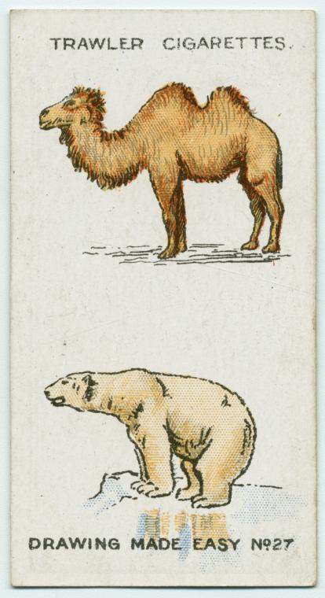

  - Polar Bear
    - Polar bear has thick fur and fat beneath its skin to insulate it.
    - Their large, furry feet help to distribute their weight as they walk on a thin ice.
    - They are white which camouflages them against the snow. This helps them to hunt.
    - They are compact in shape, reducing their surface area to volume ratio; this reduces heat loss by radiation.

Extreme Plants
- Plants may be adapted to survive in dry environments by means of:
  - changes to surface area, particularly of the leaves
  - water-storage tissues
  - extensive root systems.

- Desert plants
- Eg the cactus, require very little water to survive
- Leaves are spines.
- Spines guard against most browsing herbivorous animals.
- Spines also reduce their surface area, reducing water loss by evaporation
- A thick waxy coating surrounds the plant to reduce evaporation.
- Fewer 'stomata', reducing water loss
- Roots tend to spread sideways to catch rain water.

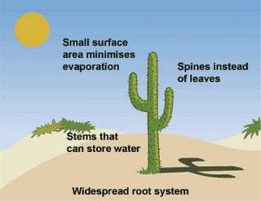
- Arctic plants
- Many of the plants are small, growing close to the ground and very close together to avoid the wind and conserve heat.
- Some possess a light, fuzzy covering to insulate the buds so they can grow.
- Many are dark colors of blue and purple to absorb the heat from the sunlight even during the winter months.
- Because of the cold and short growing seasons, arctic plants grow very slowly.
- Some grow for ten years before they produce any buds for reproduction.

Microorganisms
- Microorganisms have adaptations that enable them to survive in different environments.
- Slime capsule around some bacterial cell wall sticks them to surfaces and prevents them drying out.
- Some have the ability to form spores to survive when conditions are harsh.
- Some microorganisms have flagella which enable them to move around quickly.
- Bacteria undergo rapid reproduction when conditions are favourable.
- Some bacteria can survive extreme conditions:
  - Temperatures as little as -15°C to as high as 121°C
  - pH values 0.0 to 12.8
  - High levels of pressure deep in the oceans
  - High salt concentrations
  - Very dry conditions.

Environmental change
- Changes in the environment affect the distribution of living organisms.
- For example, the changing distribution of some bird species and the disappearance of pollinating insects including bees.
- Animals and plants are subjected to environmental changes.
- Such changes may be caused by living or non-living factors.

Non-living (abiotic) factors:
- Light
- Oxygen
- Water
- Temperature

Living (biotic) factors:
- Food
- Predation
- Grazing
- Disease
- Competition – for: food, light, water, space.

Living organisms can be used as indicators of pollution:
- Lichens are symbiotic associations of algae and fungi species that attach to tree trunks and rock.
- They are sensitive to changes in air quality.
- They are very sensitive to sulphur dioxide (SO₂) pollution in the air.
- This is released from industry and burning fossil fuels, especially coal.
- Lichens absorb sulphur dioxide dissolved in water.
- It destroys the chlorophyll in the algae preventing it from photosynthesising and killing the lichen.
- Some species only grow in non-polluted air.
- Some species grow in polluted air.
- These lichens can be used as air pollution indicators.

- Invertebrate animals are sensitive to changes in the concentration of dissolved oxygen in water.
- Oxygen concentrations decrease when pollutants are released into rivers and lakes.
- Some invertebrates survive in low-oxygen concentrations.
- Some invertebrates can only survive in higher oxygen concentrations.
- These invertebrate animals can be used as water pollution indicators.

Non-living indicators.
- Environmental changes can be measured using non-living indicators.
- For example. oxygen levels, temperature and rainfall.
- Scientists continually monitor these factors to show trends in environmental changes

B1.5 Energy and biomass in food chains

Summary
By observing the numbers and sizes of the organisms in food chains we can find out what happens to energy and biomass as it passes along the food chain.

Energy transfer
- Radiation from the Sun is the source of energy for most communities of living organisms.
- Green plants and algae capture a small part of the solar energy which reaches them.
- This energy is stored in the substances which make up the cells of the plants.
- Food chain = diagram to represent feeding relationships between organisms, showing direction of energy flow.
- At each stage in a food chain, less material and less energy are contained in the biomass of the organisms.
- The amounts of material and energy contained in the biomass of organisms is reduced at each successive stage in a food chain because:
  - some materials and energy are always lost in the organisms’ waste materials
  - respiration supplies all the energy needs for living processes, including movement.
- Much of this energy is eventually lost as heat to the surroundings

Pyramids of biomass
- The biomass at each stage can be drawn to scale and shown as a pyramid of biomass.
- Biomass = mass of living material

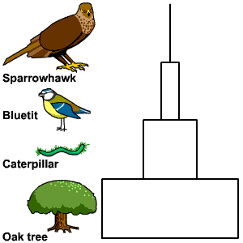

- All pyramids of biomass are pyramid shaped
- The mass of living material (biomass) at each stage in a food chain is less than it was at the previous stage.
B1.6 Waste materials from plants and animals

Summary
Many trees shed their leaves each year and most animals produce droppings at least once a day. All plants and animals eventually die. Microorganisms play an important part in decomposing this material so that it can be used again by plants. The same material is recycled over and over again and can lead to stable communities.

Recycling in ecosystems
- Living things remove materials from the environment for growth and other processes.
- These materials are returned to the environment either in waste materials or when living things die and decay.
- Materials decay because they are broken down (digested) by microorganisms (decomposers).
- Microorganisms digest materials faster in warm, moist conditions.
- Many microorganisms are also more active when there is plenty of oxygen – aerobic conditions.
- The decay process releases substances which plants need to grow.
- In a stable community, the processes which remove materials are balanced by processes which return materials.
- The materials are constantly cycled.

Carbon Cycle
- The constant cycling of carbon in ecosystems.

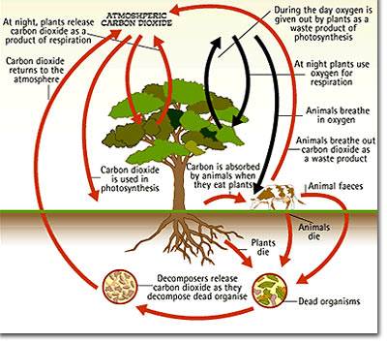
- Carbon dioxide is removed from the environment by green plants and algae for photosynthesis.
- The carbon from the carbon dioxide is used to make carbohydrates, fats and proteins which make up the body of plants and algae.
- Some of the carbon dioxide is returned to the atmosphere when green plants and algae respire.
- When green plants and algae are eaten by animals and these animals are eaten by other animals, some of the carbon becomes part of the fats and proteins which make up their bodies.
- When animals respire some of this carbon becomes carbon dioxide and is released into the atmosphere.
- When plants, algae and animals die, some animals (detritus feeders) and microorganisms (decomposers) feed on their bodies.
- Carbon is released into the atmosphere as carbon dioxide when these organisms respire.
- By the time the microorganisms and detritus feeders have broken down the waste products and dead bodies of organisms in ecosystems and cycled the materials as plant nutrients, all the energy originally captured by green plants has been transferred.
- Combustion of wood and fossil fuels releases carbon dioxide into the atmosphere.

B1.7 Genetic Variation and Its Control

Summary
There are not only differences between different species of plants and animals but also between individuals of the same species. These differences are due partly to the information in the cells they have inherited from their parents and partly to the different environments in which the individuals live and grow. Asexual reproduction can be used to produce individuals that are genetically identical to their parent. Scientists can now add, remove or change genes to produce the plants and animals they want.

Genetic material
- A cell is the basic unit of life; all organisms are made up of cells.
- The nucleus is a large organelle found in all cells, that contains the genetic information. (Even red blood cells once had a nucleus).
- Chromosomes are thread-like structures made of DNA found in the nucleus
- Genes are small sections of a chromosome that control the characteristics of an organism.
- These are passed on from parent to offspring, resulting in offspring of plants and animals having similar characteristics to their parents. Eg hair colour and petal colour
- Different genes control the development of different characteristics of an organism.

Sexual reproduction
- Involves two parents.
- They produce male and female sex cells (gametes).
- In humans these are sperm and eggs.
- Fertilisation occurs - the joining (fusion) of male and female gametes.
- The mixture of the genetic information from two parents leads to variety in the offspring.
- Genes are passed on in the gametes, from which the offspring develop.

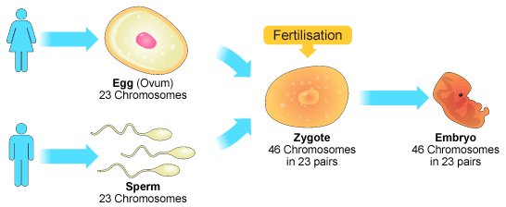

Asexual reproduction
- Involves only one individual as a parent.
- There is no fusion of gametes.
- There is no mixing of genetic information and so no variation in the offspring.
- These genetically identical individuals are known as clones.
- Examples:
- Bacteria or yeast cells use binary fission
- Plants can use runners, bulbs or vegetative propagation.
- Some invertebrate animals like starfish and hydra can produce asexual offspring.
The causes of variation
- Differences in the characteristics of different individuals of the same kind may be due to differences in:
- the genes they have inherited (genetic causes)
- the conditions in which they have developed (environmental causes)
- or a combination of both.

Genetic factors
- Sexual reproduction - leads to genetic variety in the offspring.
  - All offspring (except for identical twins) inherit different characteristics.
- Asexual reproduction – no genetic variation in the offspring (unless mutations occur)

Environmental factors
- Nutrition
- Temperature
- Light
- Physical forces

Cloning
- Humans can carry out various procedures to create clones of plants and animals.
- These new individuals are genetically identical to the parents.
- New plants can be produced quickly and cheaply by taking cuttings from older plants.

Modern cloning techniques include:

Tissue culture
- This uses small groups of cells from part of a plant to grow new plants.

Embryo transplants
- This involves splitting apart cells from a developing animal embryo before they become specialised.
- The identical embryos are then implanted into the wombs of host mothers

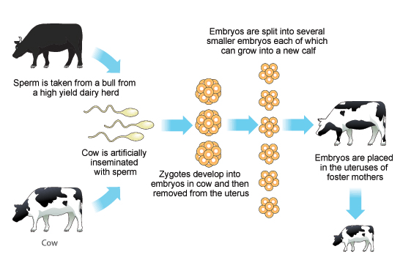
Advantages:
- This technique could be used to make many copies of cows that have a high milk yield.
- It would produce a herd of cows much faster than if the original cow was used for breeding in the normal way.

Concerns:
- People do not want this procedure to be used in humans.
- It could be used to provide more embryos for scientific testing.

Adult cell cloning
- The nucleus is removed from an unfertilized egg cell.
- This is replaced with the nucleus of an adult cell (eg skin cell).
- An electric shock is used to start the cell dividing to form embryo cells.
- These embryo cells contain the same genetic information as the adult skin cell.
- When the embryo has developed into a ball of cells, it is inserted into the womb of an adult female to continue its development.

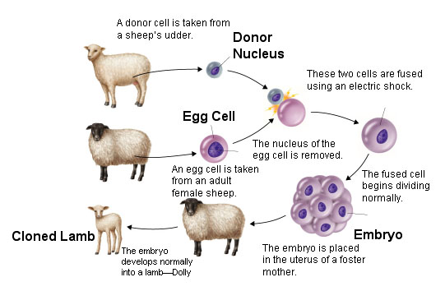
Advantages:
- This could be used to clone animals with desired characteristics, eg farm animals.
- It could possibly be used to save animals from extinction.

Concerns:
- People do not want human babies to be cloned.
- If this is used in farming, it produces lots of genetically identical individuals;
- If there is a change in the environment, they may all struggle to survive.

Genetic engineering
- Genes from the chromosomes of humans and other organisms can be cut out using enzymes and transferred to cells of other organisms.

Examples of uses in medicine:
- Vaccine production
- Production of insulin for diabetics.

The process:
  - Cut out the insulin gene from the DNA of a human cell using an enzyme.
  - Remove a ring of DNA from a bacterium and open it up using the same enzyme.
  - Insert the insulin gene into the plasmid using another enzyme.
  - Enable a bacterium to take up the altered DNA.
  - Put the bacterium in a fermenter, and it multiplies many times.
  - Each new bacterium contains the insulin gene.
  - The bacteria produce insulin which can be extracted.

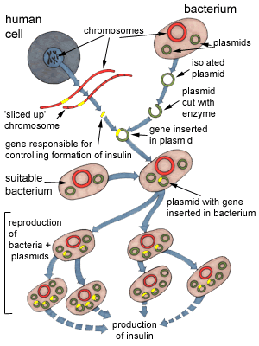

Other uses of genetic engineering
- Genes can also be transferred to the cells of animals or plants at an early stage in their development so that they develop with desired characteristics.
- This could be used to insert ‘healthy’ genes into an embryo that has a genetic disease.
- New genes can also be transferred to crop plants
- Crops that have had their genes modified in this way are called genetically modified crops (GM crops).
- Examples of genetically modified crops include ones that are resistant to insect attack or to herbicides.
- GM crops generally show increased yields.

Concerns:
- Long-term, unpredicted effects of consuming GM plants on human health.
- Genes for pesticide resistance may spread from GM plants to their wild relatives, creating pesticide resistant weeds.
- People may want to manipulate the genes of their future children.
B1.8 Evolution

Summary
Particular genes or accidental changes in the genes of plants or animals may give them characteristics which enable them to survive better. Over time this may result in entirely new species. There are different theories of evolution. Darwin’s theory is the most widely accepted.

Darwin
- Darwin’s theory of evolution by natural selection states that all species of living things have evolved from simple life forms that first developed more than three billion years ago.
- These first organisms were very simple single-celled organisms, similar to bacteria.
- The theory of evolution by natural selection was only gradually accepted because:
  - the theory challenged the idea that God made all the animals and plants that live on Earth
  - there was insufficient evidence at the time the theory was published to convince many scientists
  - the mechanism of inheritance and variation was not known until 50 years after the theory was published.

Conflicting theories on evolution
- Scientists may produce different hypotheses to explain similar observations.
- Before Darwin, Lamarck used a different theory.

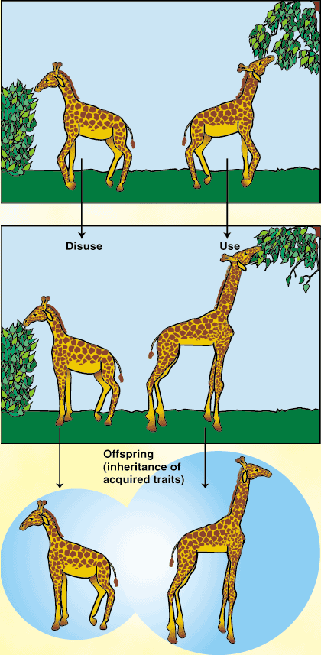

- He proposed a theory of acquired characteristics.
- He argued that an individual’s characteristics will change over its lifetime due to amount of use.
- Eg. Giraffes necks get longer due to stretching for leaves.
- Then he suggested that these characteristics could be inherited.
- We now know that in the vast majority of cases this type of reproduction cannot occur.
- Changes in the body do not change the genes.

Classification
- Studying the similarities and differences between organisms allows us to classify living organisms into animals, plants and microorganisms.
- This helps us to understand evolutionary and ecological relationships.
- Models allow us to suggest relationships between organisms.
- Evolutionary trees (models) are used to represent the relationships between organisms.
- This tree indicates how long ago the ancestors of ape species diverged from each other.
- It indicates that humans share a common ancestor with chimpanzees more recently than with any other ape species.

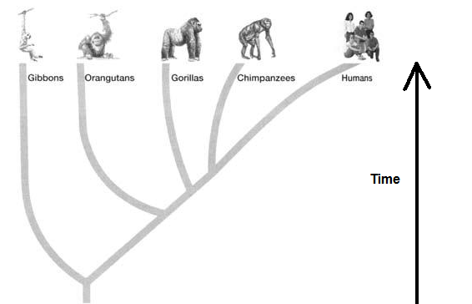

Darwin’s theory of natural selection
- Organisms produce large numbers of offspring
- Individual organisms within a particular species may show a wide range of variation because of differences in their genes

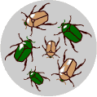

- There is a struggle for all organisms to exist (eg. Predation)

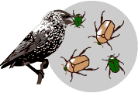

- Individuals with characteristics most suited to the environment are more likely to survive to breed successfully
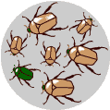

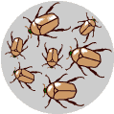
- The genes which have enabled these individuals to survive are then passed on to the next generation.

- Gradually, this can result in changes in the characteristics of a species.

Mutations

- How do mutations occur?
- Errors occur when the DNA is replicated prior to cell division.
- Errors may occur when chromosomes are separated during cell division.

- What do mutations do?
- Genes control the synthesis of proteins.
- Therefore a change in a gene or a new sequence of genes can result in different proteins being synthesised.
- This can change a characteristic.

- Most mutations are harmful or fatal.
- Occasionally, some mutations are useful.
- When new forms of a gene result from mutation, and they give rise to useful characteristics, there may be more rapid change in a species if the environment changes.

