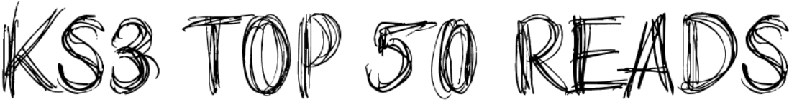
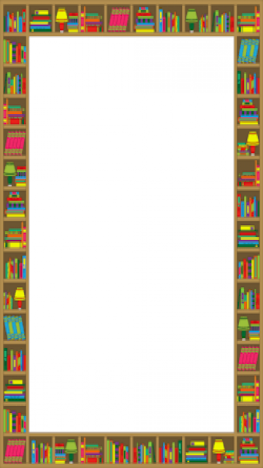

- Boy by James Mayhew (1.6)
- Oliver Twist: Retold by Maggie Pearson (3.4)
- Rooftoppers by Katherine Rundell (3.5)
- The Bubble Boy by Stewart Foster (3.6)
- Diary of an (Un)Teenager by Pete Johnson (3.7)
- Apple and Rain by Sarah Crossan (3.8)
- The Disconnect by Keren David (4.0)
- Noughts and Crosses by Malorie Blackman (4.0)
- The London Eye Mystery by Siobhan Dowd (4.1)
- Still Water by Chris Priestley (4.2)
- Holes by Louis Sachar (4.6)
- The Most Peculiar Toy Factory by Alex Bell (4.6)
- The Witches by Roald Dahl (4.7)
- Wonder by R.J. Palacio (4.8)
- The Art of being Normal by Lisa Williamson (4.8)
- A Monster Calls by Patrick Ness (4.8)
- The Children of Blood and Bone by Toni Adeyemi (4.8)
- Matilda by Roald Dahl (5.0)
- The Goldfish Boy by Lisa Thompson (5.0)
- The Secret Diary of Adrian Mole aged 13-¾" by Sue Townsend (5.1)
- Goodnight Mister Tom by Michelle Magorian (5.1)
- The 1000-year-old Boy by Ross Welford (5.1)
- Coraline by Neil Gaiman (5.1)
- The Hunger Games by Suzanne Collins (5.3)
- The Boy at the Back of the Class by Onjali Q. Rauf (5.4)
- The Curious Incident of the Dog in the Night- Time by Mark Haddon (5.4)

- When Hitler Stole Pink Rabbit by Judith Kerr (5.7)

- The Lion, The Witch and The Wardrobe by C.S Lewis (5.7)
- The Boy in the Striped Pyjamas by John Boyne (5.8)
- War Horse by Michael Morpurgo (5.9)
- Northern Lights/The Golden Compass by Philip Pullman (6.2)
- Murder on the Orient Express by Agatha Christie (6.2)
- The Secret Garden by Frances Hodgson Burnett (6.3)
- The Diary of a Young Girl by Anne Frank (6.5)
- The Hobbit by J.R.R Tolkien (6.6)
- The Hitchhikers Guide to the Galaxy by Douglas Adams (6.6)
- I am Malala by Malala Yousafzai (7.1)
- Animal Farm by George Orwell (7.3)
- Alice’s Adventures in Wonderland by Lewis Carroll (7.4)
- Little Women by Louisa May Alcott (7.5)
- Peter Pan by James Matthew Barrie (7.7)
- Black Beauty by Anna Sewell (7.7)
- The Adventure of Tom Sawyer by Mark Twain (8.0)
- Treasure Island by Robert Louis Stevenson (8.3)
- The Hound of the Baskervilles by Arthur Conan Doyle (8.3)
- The Count of Monte Cristo by Alexandre Dumas (8.8)
- Oliver Twist by Charles Dickens (11.3)
- Pride and Prejudice by Jane Austen (12.0)
- Stories for Boys Who Dare to the Different by Ben Brooks (no AR)
- Good Night Stories for Rebel Girls by Elena Favilli (no AR)

